 | 
COUNCIL ASSESSMENT REPORT
HUNTER AND CENTRAL COAST REGIONAL PLANNING PANEL

PANEL REFERENCE & DA NUMBER | PPSHCC-374 – DA2025/0571
PROPOSAL | 204 Multi-Dwelling Development
ADDRESS | Lot 2 DP 1022067  106 Forest Lane, Old Bar.
APPLICANT | Palm Lake Works Pty Ltd
OWNER | Palm Lake Resort Pty Ltd
DA LODGEMENT DATE | 4 August 2025
APPLICATION TYPE | Integrated DA
REGIONALLY SIGNIFICANT CRITERIA | Section 2, Schedule 6 of State Environmental Planning Policy (Planning Systems) 2021 : General development with a cost of works exceeding $30 million.
CIV | $147,513,650.90
CLAUSE 4.6 REQUESTS | Not applicable.
KEY SEPP/LEP | Biodiversity and Conservation SEPP, Greater Taree LEP
TOTAL & UNIQUE SUBMISSIONS KEY ISSUES IN SUBMISSIONS | Zero (0)
DOCUMENTS SUBMITTED FOR CONSIDERATION | - Attachment B – Plans  - Attachment C – Staging Plan  - Attachment D – Statement of Environmental Effects  - Attachment E – Civil Plans  - Attachment F – Stormwater Letter  - Attachment G – Bushfire Report  - Attachment H – Traffic Report  - Attachment I – Traffic Report Addendum  - Attachment J – Statement of Landscape Intent  - Attachment K – Flood Imperviousness Assessment  - Attachment L – Waste Management Plan
RECOMMENDATION | Approval
DRAFT CONDITIONS TO APPLICANT | No.
SCHEDULED MEETING DATE | 13 October 2026
PREPARED BY | Craig Wilkinson, Senior Development Planner,  MidCoast Council
DATE OF REPORT | 6 October 2026

EXECUTIVE SUMMARY

The development application (DA2025/0571) seeks consent for a 204 multi-dwelling development, which is intended to be delivered as manufactured homes.

The subject site is known as 106 Forest Lane, Old Bar (‘the site’) with predominant road frontage to Forest Lane. The site is an irregular shape with an area of 51.3Ha. The development itself only occupies an area of ~11.25Ha.

Existing development on the site consists of a residential dwelling and ancillary structures including a detached shed and inground pool.

The site is located on the edge fo the existing urban area of Old Bar. The surrounding area comprises predominantly low density detached dwellings to the north and west, including a manufactured home estate directly to the north. There is vacant land to the eaast , which is approved for a future manufacture home estate, and land to the south is vacant vegetated lands.

The site contains multiple land zones, however the proposal is located in the R1 – General Residential land zone portion of the site pursuant to Clause 2.2 of the Greater Taree Local Environmental Plan 2010 (‘LEP 2010’). Multi-dwelling housing is permissible with consent in the R1 zone.

The application was exhibited from 11 August 2025 to the 15 September 2025. As a result, the application received no public submissions.
The application was referred to NSW Rural Fire Service and DPE-Water for comment as integrated development pursuant to Section 4.46 of the Act and in accordance with the Rural Fires Act 1997 and the Water Management Act 2000.
The development has been assessed against applicable State, Regional, and Local Environmental Planning Instruments and Policies, including:
- Environmental Planning and Assessment Act 1979
- Environmental Planning and Assessment Regulation 2021
- State Environmental Planning Policy (Biodiversity and Conservation) 2021
- State Environmental Planning Policy (Planning Systems) 2021
- State Environmental Planning Policy (Resilience and Hazards) 2021
- Greater Taree Local Environmental Plan 2010
- Greater Taree Development Control Plan 2010
- Greater Taree Section 94 Development Contributions Plan.

The application is referred to the Hunter and Central Coast Regional Planning Panel (‘the Panel’) as the development is ‘regionally significant development’, pursuant to Section 2.19(1) and Section 2 of Schedule 6 of State Environmental Planning Policy (Planning Systems) 2021 as the proposal is general development with a value over $30 million.

The principal planning controls relevant to the proposal include State Environmental Planning Policy (Resilience and Hazards) 2021 and the Greater Taree Local Environmental Plan 2010 (‘LEP’) and the Greater Taree Development Control Plan (‘DCP’). The proposal is consistent with the relevant provisions of the planning controls

Following consideration of the matters for consideration under Section 4.15(1) of the EP&A Act, the provisions of the relevant State environmental planning policies, it is considered that the proposal can be supported.

Following a detailed assessment of the proposal, pursuant to Section 4.16(1)(b) of the EP&A Act, DA2025/0571 is recommended for approval subject to the conditions contained in Attachment A of this report.

- THE SITE AND LOCALITY

  - The Site

The subject site is identified as Lot 2 DP 1022067, being known as 106 Forest Lane, Old Bar. With an area of 51.3Ha, the site is an irregular shape, with boundaries which typically border residential developments to the north, east and west. The subject site is located approximately 1km from the Old Bar CBD and 13km from the Taree CBD.

The site has a frontage to Forest Lane to the north along with a number of minor frontages to other roads. There is scattered vegetation located across the site, however this is predominantly concentrated in the central portion of the site (very little vegetation is located within the development footprint). There is also an existing shed located on the site as well as a water course which traverses the site. The site has an area of 51.3Ha, however the development only occupies a portion of the site, being ~11.25Ha.

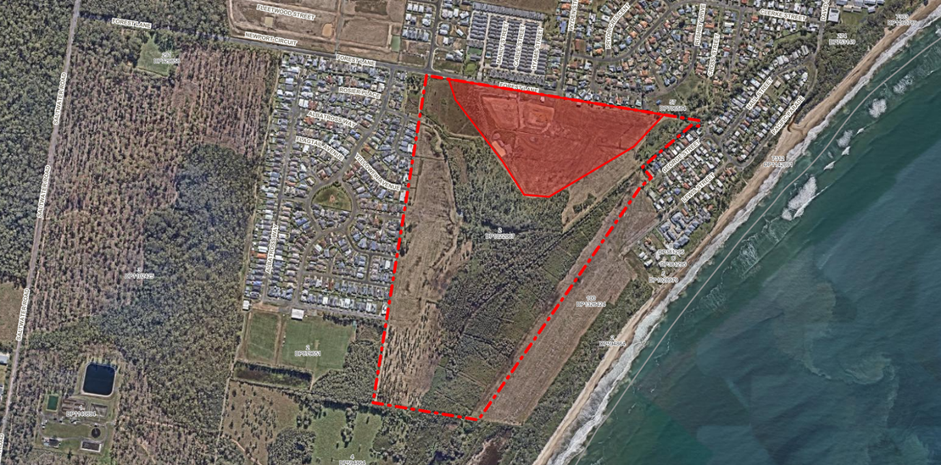
Development area within site shown shaded red.
Figure 1: Site Aerial Imagery

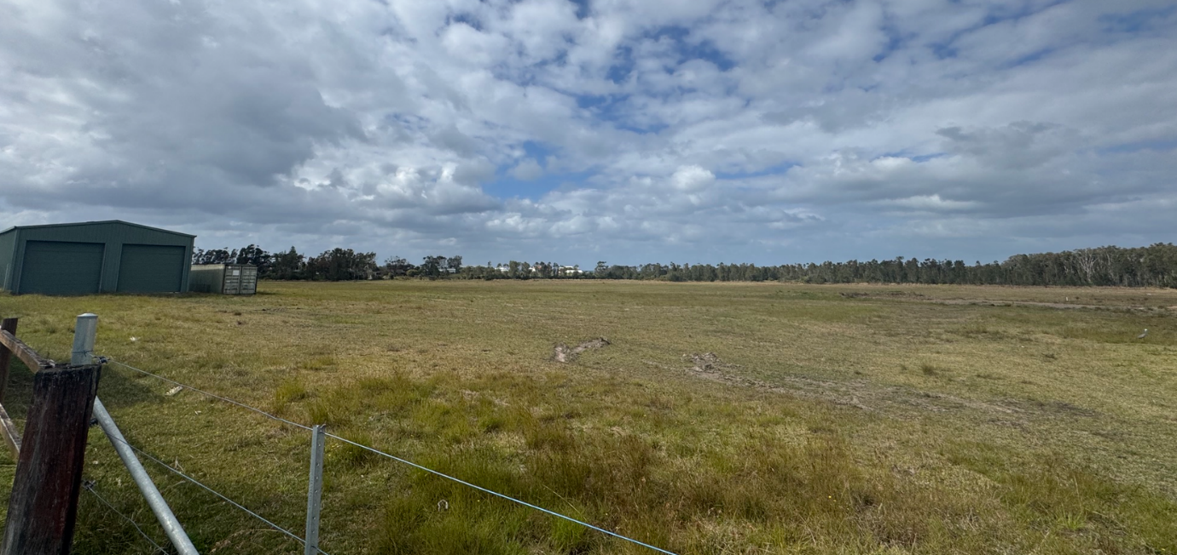
Figure 2: View of the site from the frontage of Forest Lane

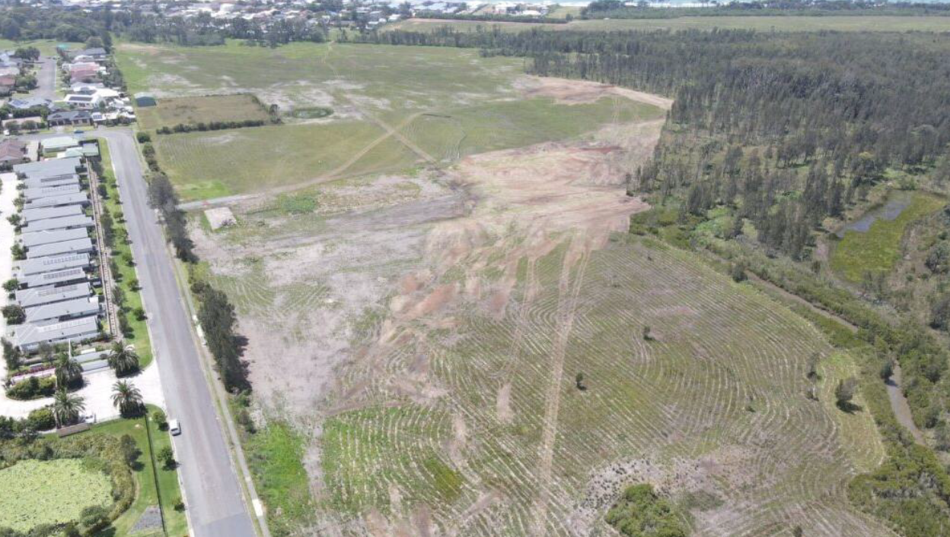
Figure 3: Aerial image of the site looking south-east (Source: Applicant)
  - The Locality

The locality surrounding the development site is predominantly residential dwellings to the north, west and east. In addition to this there is also sports fields located to the south-west fo the site. The dwellings surrounding the site are typically detached dwellings of a low density. It is noted that there is a manufactured home estate directly opposite the site to the north.

The site is located on the outer urban fringe of Old Bar in an area which has been subject to recent development through residential subdivisions as well as a manufactured home estate. It is noted that the proponent also owns the land adjacent to the east, which benefits from an approval for a manufactured home estate.

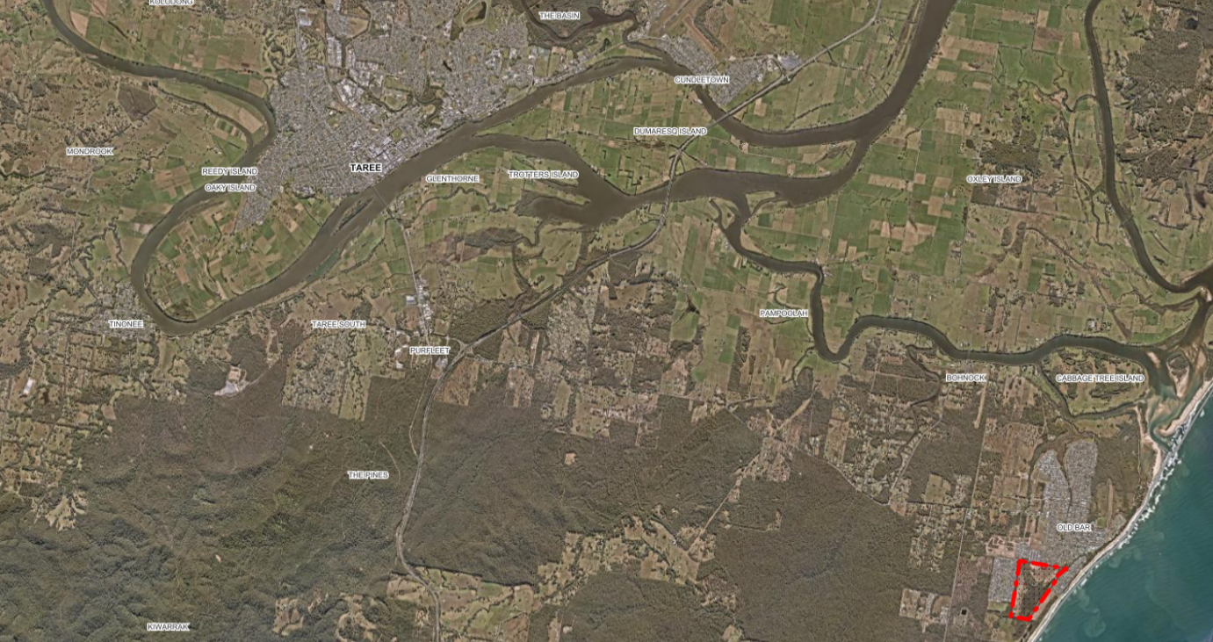
Taree
Old Bar
Subject Site
Figure 4: Site Locality/Context Map
- THE PROPOSAL AND BACKGROUND

  - The Proposal

The application proposes a multi-dwelling development, which includes 204 dwellings, as well as communal spaces and facilities (footpaths, BBQ spaces, and parklets/pocket parks). The proposal includes access from the intersection of Forest Lane and Wyden Street, with no direct vehicle access from any of the other frontages. The dwellings will be serviced by internal access roads which traverse the site.

The dwellings are intended to be delivered as manufactured homes with a total of 16 different designs/configurations. A dwelling typology and configuration plan has been supplied which nominates a dwelling type for each ‘lot’. This plan defines where each dwelling type will be located, including nomination of two-storey dwellings.

To facilitate the proposal, the existing shed will be demolished.

The development is intended to be delivered in nine (9) stages.

Note: It is acknowledged that operationally this will function as an MHE…

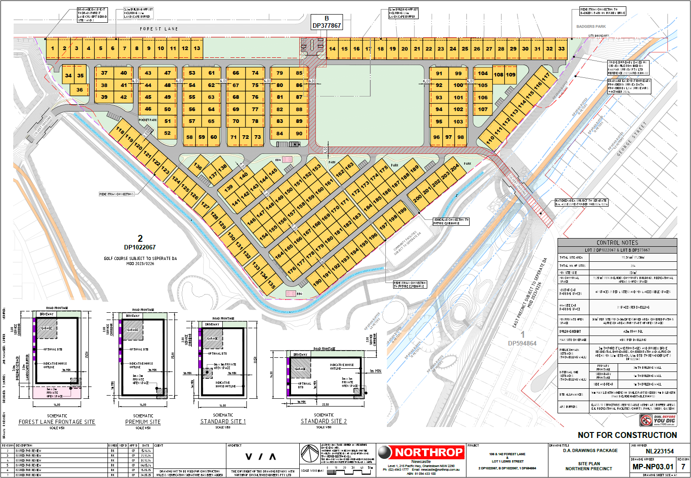
Figure 5: Development Layout

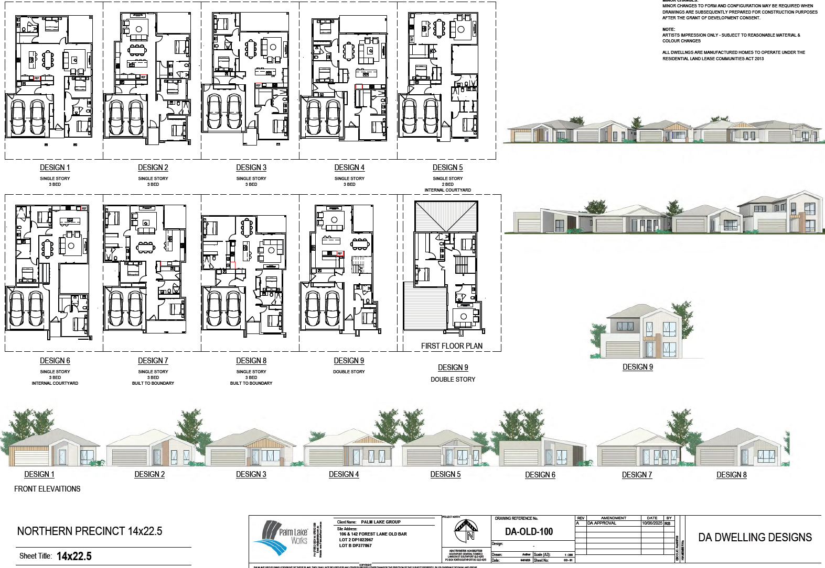
Figure 6: Dwelling Layouts Overview Plan

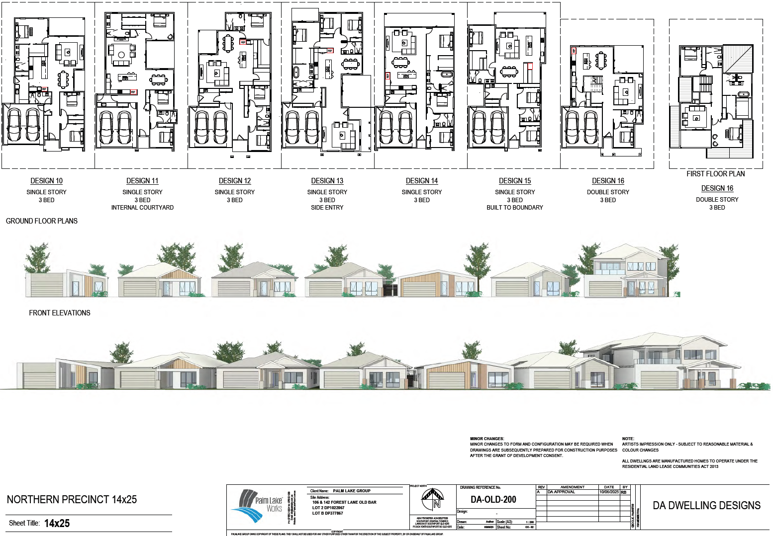
Figure 7: Dwelling Layouts Overview Plan
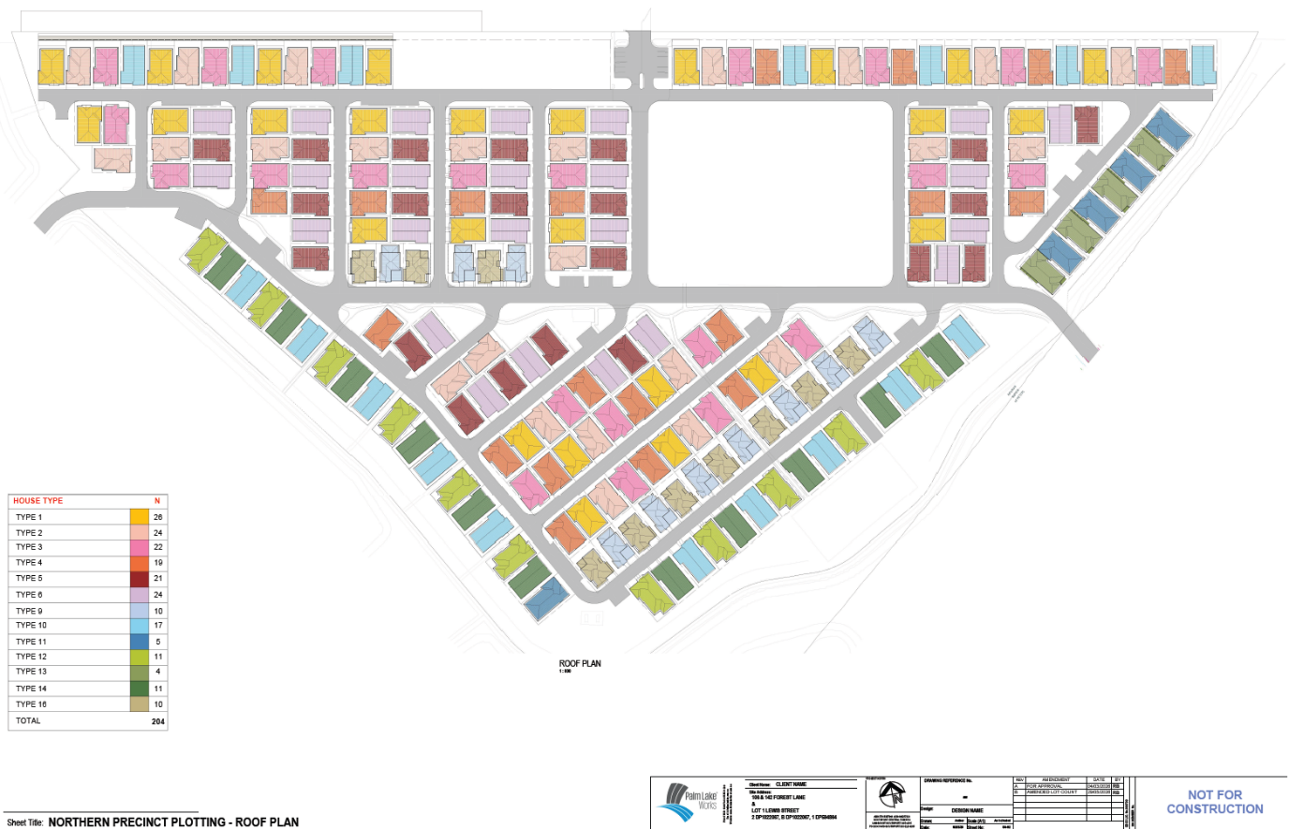
Figure 8: Dwelling Configuration Plan

Table 1: Development Data
Control | Proposal
Site area | 51.3Ha
FSR | 0.53:1
Max Height | 7.87m
Clause 4.6 Requests | No
No of dwellings | 204

  - Site Background and Development Linkages

The site has remained vacant for an extensive period and currently remains a semi-rural parcel of land on the fringe of the Old Bar urban area. Notwithstanding this, the site has been subject to several development approvals, a number of which are relevant to this application. A summary of the approvals and their linkage to this application is discussed further below:

Development Reference | Linkage and Impacts on Development
488/1999/DA  (Golf Course) | Proposed golf course which sits within the same lot and is adjacent to development area.  The golf course provides the stormwater management system for the development.  The development is reliant on the delivery of the stormwater works facilitated through 488/1999/DA to ensure appropriate stormwater measures are in place.  This is required to be conditioned to ensure that the delivery of the relevant stage of 488/1999/DA is delivered prior to this development commencing works.
169/2010/DA  (Manufactured Home Estate) | Development sits adjacent to the proposed development on adjoining land.  The development of this multi-dwelling development is not directly reliant on any outcomes of 169/2010/DA.  Conversely, the development of 169/2010/DA is reliant on access through the development site to gain access to Forest Lane and Wyden Street.  The latest approval for 169/2019/DA includes a requirement for a s.88B instrument to be imposed on the land for a right of carriageway.
439/2014/DA  (Concept DA – Subdivision) | Application 439/2014/DA is the Concept DA that the development is required to be consistent with.  The Concept DA was modified to allow for the creation of ‘super lots’ to permit the progression of multi-dwelling housing on the site.  It is considered that the development is consistent with the concept DA (as discussed elsewhere in this report).
229/2018/DA  (Bulk Earthworks) | Application 229/2018/DA was approved to establish the bulk earthworks necessary to facilitate the future development of the site.  The was required to address flood level issues and stormwater management.  The development is reliant on these works being facilitated to ensure that there is appropriate area for the development that is above the flood planning level.  The development is require dot be conditioned to ensure that the works under 229/2018/DA are completed prior to works commencing.
DA2025/0674  (Clubhouse) | Application DA2025/0674 is for a clubhouse located within the development footprint. The clubhouse is proposed to be located within the cleared area within the central portion of this development.  Consent has been issued for DA2025/0674, however it has been conditioned to ensure that works cannot commence until such time that works commence on this development.

488/1999/DA (Latest approved modification: MOD2023/0226) – Golf Course:

Background: An 18-hole golf course was originally approved on the site on 15 February 2000. The application was subsequently modified on 20 August 20008 to alter the layout of the golf course as well as introduce a two-phase staging to the development. The golf course was again modified on 20 September 2024 to remove stage 2 (essentially making it a 9-hole golf course) as well as incorporating stormwater management and flood strategies for the broader area and development site.
Linkage to Current Development: The golf course development provides the broader stormwater management for the development, as well as the broader area. The development is reliant on the delivery of these stormwater works in order to be able to be constructed. Accordingly, the development is required to be conditioned to ensure that the stormwater works proposed under Stage 1 of 488/199/DA (MOD2023/0226) are completed prior to works commencing (including issuing of a Construction Certificate).

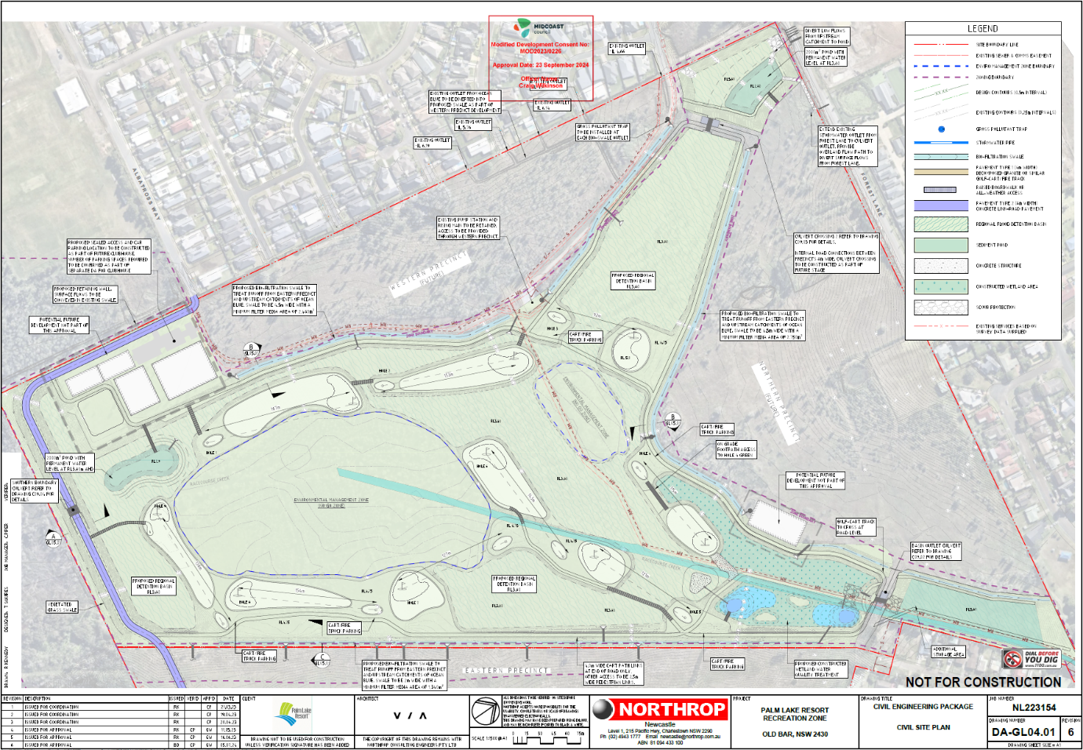

439/2014/DA (Latest approved modification: MOD2025/0068) – Concept DA for the subdivision of land:

Background: Consent was granted across a number of sites for a Concept DA for 522 residential Lots. The Concept DA included Stage 1 (62 Lots) and was approved on 2 May 2016. The Concept Subdivision was located on a number of sites, including the development site. Through amendments to the original concept DA, changes were made to the original subdivision layout to allow for the lodgement of a multi-dwelling application. This change was facilitated through MOD2022/0277, which created the site as a ‘super lot’ and removed the concept overlay of a subdivision layout. This amendment allows for the consideration of an alternate arrangement, including the multi-dwelling development proposal, currently being considered through this application.

Linkage to Current Development: This development has been required to demonstrate that the proposal remains consistent with the approved concept layout of 439/2014/DA (MOD2025/0068). This is discussed elsewhere in this report.
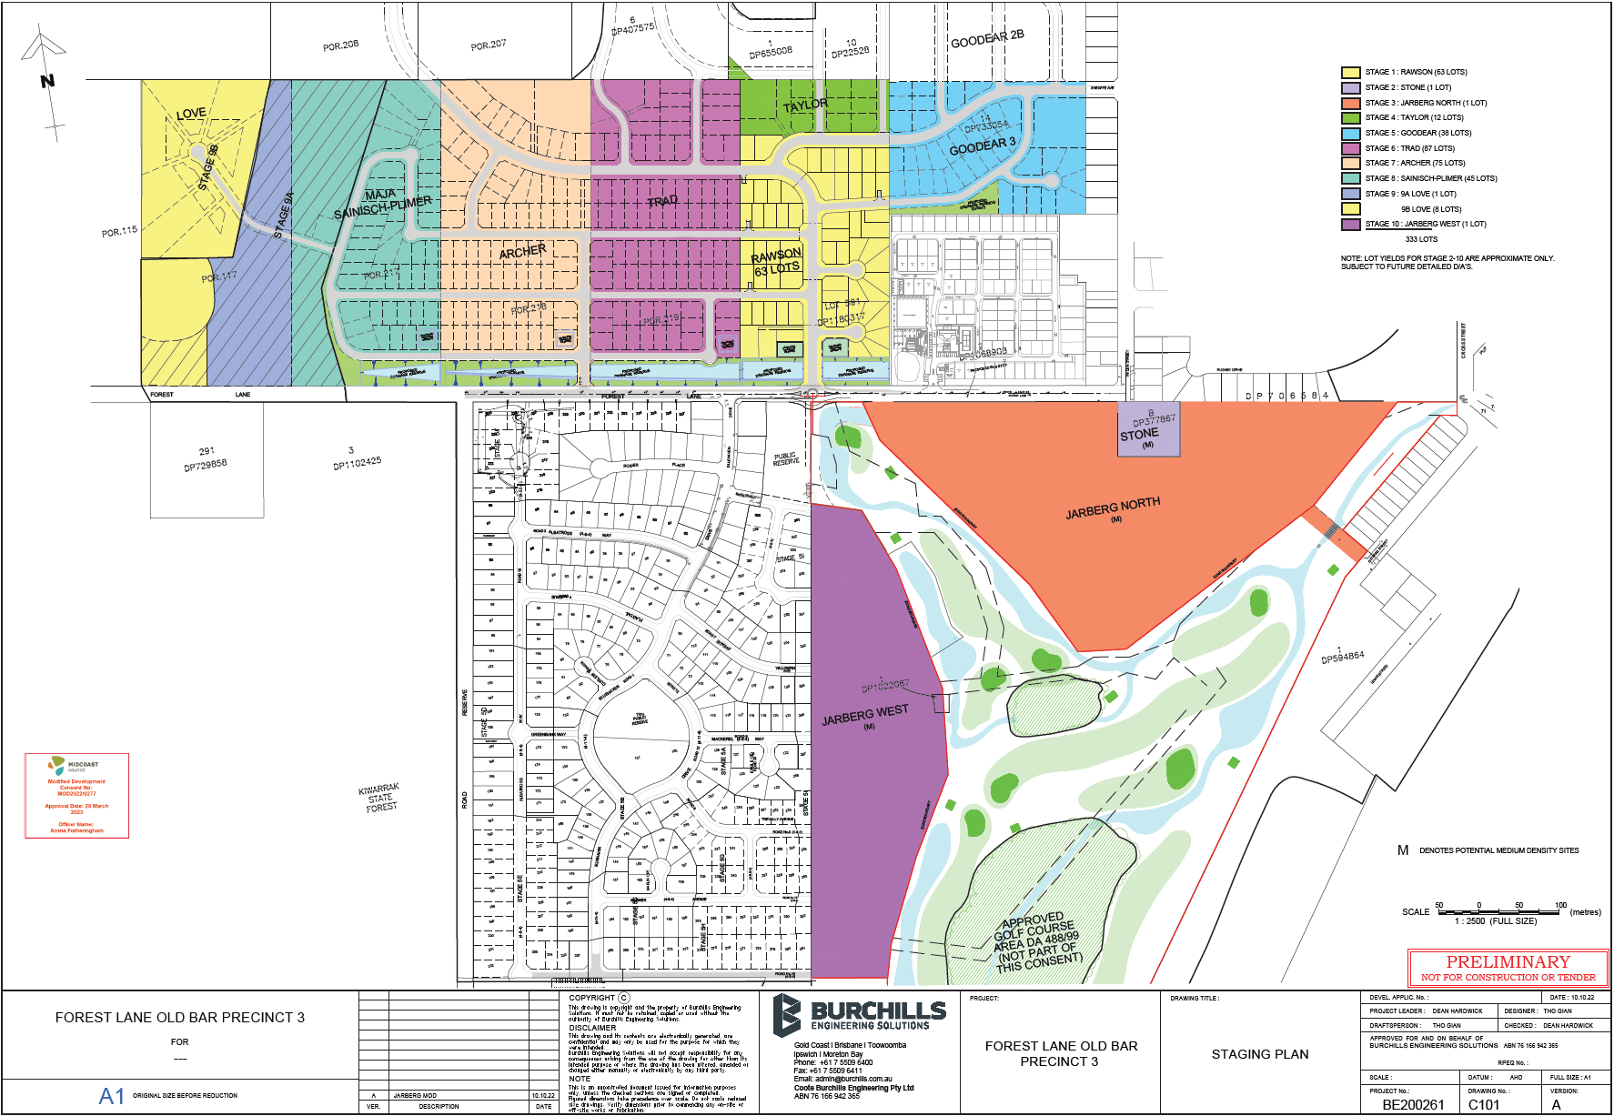

169/2010/DA (Latest approved modification: MOD2024/0214) – Manufactured Home Estate

Background: The site located to the east (Lot 100 DP 1326424) has been approved for a Manufactured Home Estate (MHE). Consent was granted on 5 February 2010 through application 169/2010/DA. The original approval was for a 201 site MHE which included communal clubhouse, outdoor pool, bowling green and tennis court. The development has been modified a number of times and the latest approval is for a 148 site MHE with ancillary facilities.
Linkage to Current Development: This development is indirectly linked to the prosed multi-dwelling development being considered under this application as it will share access with the proposal through the intersection at Forest Lane and Wyden Street.
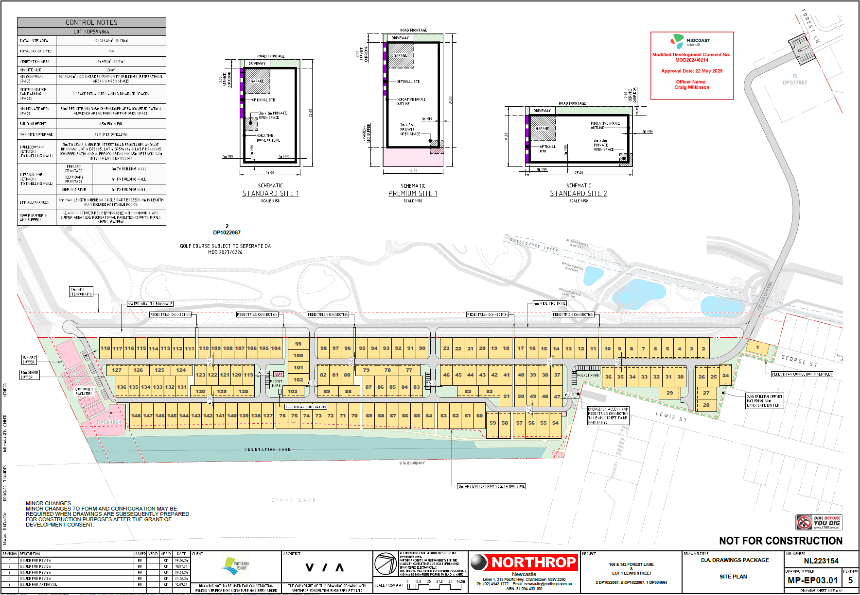

229/2018/DA (Latest approved modification: MOD2025/0026) – Bulk Earthworks

Background: Approval was granted for bulk earthworks to fill the subject site to a prescribed level which was consistent with the Concept DA (439/2014/DA), being above the flood planning level. Approval was granted for the development on 6 August 2019. The approval was issued to allow the facilitation of bulk earthworks to prepare the site for future development aligned with the concept DA.

Linkage to Current Development: The bulk earthworks are intrinsically tied to the development, as the development is reliant on these work sin order to facilitate the building areas above flood planning levels. As such, the development will be required to be conditioned to ensure that the bulk earthworks under 229/208/DA (MOD2025/0026) are completed prior to any works commencing (including issuing of a Construction Certificate).

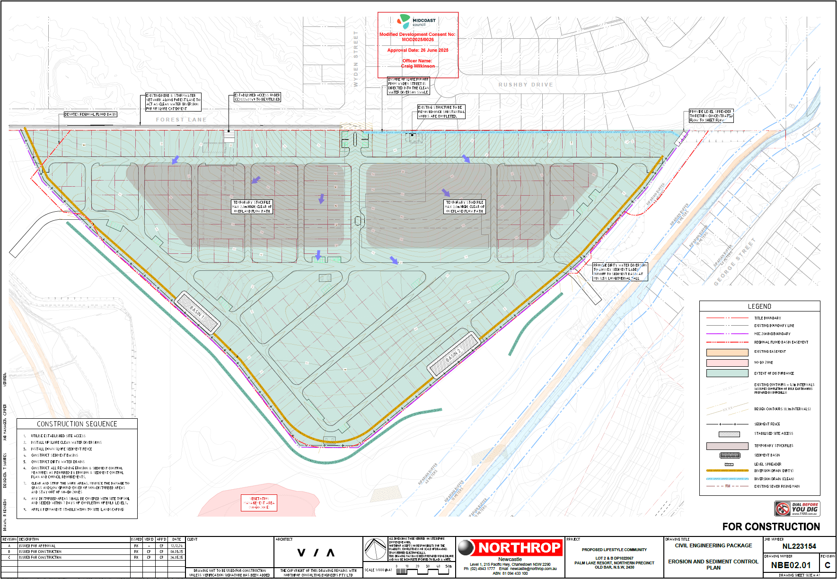

DA2025/0674 – Clubhouse

Background: Approval was granted for a Clubhouse (recreation facility) on the development site on 21 August 2026. The development proposes a clubhouse facility that is intended to be used in conjunction with the proposed multi-dwelling development that is subject to this report.

Linkage to Current Development: The development is proposed to ultimately be ancillary to the multi-dwelling development and provide the community facilities for the future occupants. To align with this, the Clubhouse has been conditioned to ensure that no works can commence until such time that works for DA2025/0571 have been commenced.

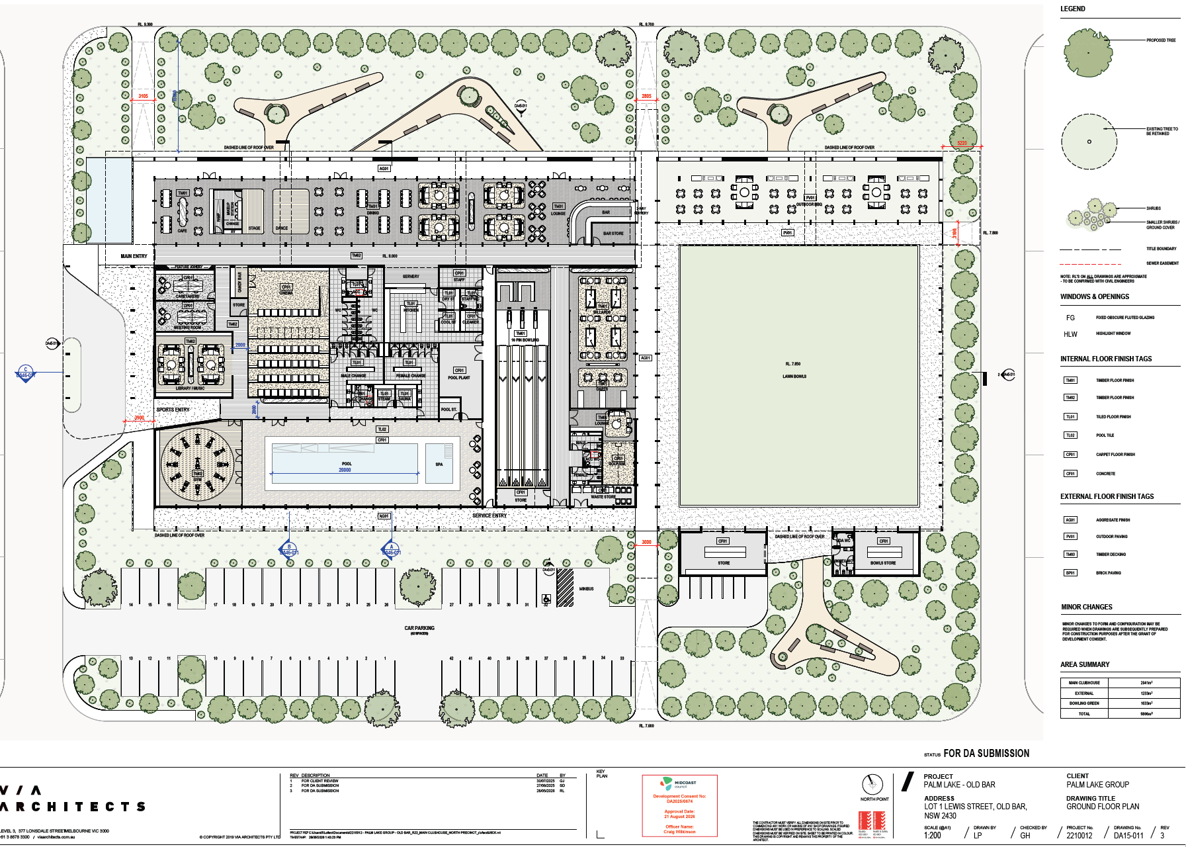

The development application was lodged on 4 August 2025. A chronology of the development application since lodgement is outlined below including the Panel’s involvement (briefings, deferrals etc) with the application:

Table 2: Chronology of the DA
Date | Event
4 August 2025 | DA lodged
8 August 2025 | DA referred to external agencies
11 August 2025 | Exhibition of the application (exhibition concluded on 15 September 2025)
17 February 2026 | Request for Information from Council to applicant
3 June 2026 | Additional details lodged. The applicant submitted details in response to the request for information.
25 June 2026 | Second Request for Information from Council to applicant
28 July 2026 | Additional details lodged. The applicant submitted details in response to the request for information.

- STATUTORY CONSIDERATIONS

When determining a development application, the consent authority must take into consideration the matters outlined in Section 4.15(1) of the Environmental Planning and Assessment Act 1979 (‘EP&A Act’). These matters as are of relevance to the development application include the following:

- the provisions of -
(i) any environmental planning instrument, and
(ii) any proposed instrument that is or has been the subject of public consultation under this Act and that has been notified to the consent authority (unless the Planning Secretary has notified the consent authority that the making of the proposed instrument has been deferred indefinitely or has not been approved), and
(iii) any development control plan, and
(iiia) any planning agreement that has been entered into under section 7.4, or any draft planning agreement that a developer has offered to enter into under section 7.4, and
(iv) the regulations (to the extent that they prescribe matters for the purposes of this paragraph),
that apply to the land to which the development application relates,
- the significant likely impacts of that development, including environmental impacts on both the natural and built environments, and social and economic impacts in the locality,
- the suitability of the site for the development,
- any submissions made in accordance with this Act or the regulations,
- the public interest.

These matters are further considered below.

It is noted that the proposal is considered to be (which are considered further in this report):

- Integrated Development (s4.46)

  - Environmental Planning Instruments, proposed instrument, development control plan, planning agreement and the regulations

The relevant environmental planning instruments, proposed instruments, development control plans, planning agreements and the matters for consideration under the Regulation are considered below.

- Section 4.15(1)(a)(i) - Provisions of Environmental Planning Instruments

The following Environmental Planning Instruments are relevant to this application:

- State Environmental Planning Policy (Biodiversity and Conservation) 2021
- State Environmental Planning Policy (Planning Systems) 2021
- State Environmental Planning Policy (Resilience and Hazards) 2021
- Greater Taree Local Environmental Plan 2010

A summary of the key matters for consideration arising from these State Environmental Planning Policies are outlined in Table 3 and considered in more detail below.

Table 3: Summary of Applicable Environmental Planning Instruments
EPI | Matters for Consideration | Comply (Y/N)
State Environmental Planning Policy (Biodiversity & Conservation) 2021 | Chapter 4: Koala Habitat Protection 2021 | Y
State Environmental Planning Policy (Planning Systems) 2021 | Chapter 2: State and Regional Development | Y
SEPP (Resilience & Hazards) | Chapter 2: Coastal Management  Chapter 4: Remediation of Land | Y
Greater Taree Local Environmental Plan 2010 | Part 2  Part 4  Part 5  Part 6  Part 7 | Y

Consideration of the relevant SEPPs is outlined below:

State Environmental Planning Policy (Biodiversity and Conservation) 2021

The provisions of SEPP (Biodiversity and Conservation) 2021 are applicable to the MidCoast local government area, and therefore, consideration of the impacts on the Koala habitat must be undertaken. It is noted that previous consideration of vegetation removal on the site has been facilitated through MOD2023/0226 and MOD2025/0026. The vegetation removal has been facilitated through these DAs and no further consideration of these matters is required.
It is noted that no further consideration of SEPP (Biodiversity and Conservation) 2021 is required.
State Environmental Planning Policy (Planning Systems) 2021

Chapter 2: State and Regional Development

The proposal is regionally significant development pursuant to Section 2.19(1) as it satisfies the criteria in Section 2 of Schedule 6 of the SEPP (Planning Systems) 2021 as the proposal is development which has an estimated development cost in excess of $30 million. Accordingly, the Hunter and Central Coast Regional Planning Panel is the consent authority for the application. The proposal is consistent with this Policy.

State Environmental Planning Policy (Resilience and Hazards) 2021

Chapter 2 – Coastal Management:
The site is identified as being within the 'Coastal Use Area' and ‘Coastal Environment Area’ in accordance with the provisions of State Environmental Planning Policy (Resilience and Hazards) 2021.
Pursuant to Sections 2.10 and 2.11, development consent must not be granted to development on land that is within the Coastal Environment Area, and Coastal Use Area unless the consent authority has considered whether the proposed development is likely to cause an adverse impact on the stated criteria listed in the table below.
Division 3 – Coastal environment area
Section 2.10(1)
Development consent must not be granted to development on land that is within the coastal environment area unless the consent authority has considered whether the proposed development is likely to cause an adverse impact on the following:

Subclause | Comment
(a) the integrity and resilience of the biophysical, hydrological (surface and groundwater) and ecological environment, | The development will have no significant impact on the integrity and resilience of the biophysical, hydrological (surface and groundwater) and ecological environment.
(b) coastal environmental values and natural coastal processes, | The development will have no significant impact on coastal environmental values and natural coastal processes.
(c) the water quality of the marine estate (within the meaning of the Marine Estate Management Act 2014), in particular, the cumulative impacts of the proposed development on any of the sensitive coastal lakes identified in Schedule 1, | The proposal will not impact water quality in any marine estate.
(d) marine vegetation, native vegetation and fauna and their habitats, undeveloped headlands and rock platforms, | The proposal will not impact on native vegetation, fauna and their habitats. The proposal does not impact headlands or rock platforms.
(e) existing public open space and safe access to and along the foreshore, beach, headland or rock platform for members of the public, including persons with a disability, | The proposal will not impact access and public space along the coastal foreshore.
(f) Aboriginal cultural heritage, practices and places: A basic AHIMS search has been conducted on the site. | There are no known items of aboriginal heritage that would be impacted by the development. A basic AHIMS search has been conducted.
(g) the use of the surf zone. | The proposal will not impact the surf zone

Division 4 – Coastal use area
Section 2.11(1)(a)
Development consent must not be granted to development on land that is within the coastal use area unless the consent authority has considered whether the proposed development is likely to cause an adverse impact on the following:

Subclause | Comment
(i) existing, safe access to and along the foreshore, beach, headland or rock platform for members of the public, including persons with a disability, | No adverse impacts on the existing, safe access to and along the foreshore, beach, headland or rock platform for members of the public, including persons with a disability, are likely to result from the development.
(ii) overshadowing, wind funnelling and the loss of views from public places to foreshores, | No overshadowing, wind funnelling or loss of views from public places to foreshores is likely to result from the development.
(iii) the visual amenity and scenic qualities of the coast, including coastal headlands, | The proposed development is not likely to have any significant adverse impact on visual amenity and scenic qualities.
(iv) Aboriginal cultural heritage, practices and places, | There are no known items of aboriginal heritage that would be impacted by the development. A basic AHIMS search has been conducted.
(v) cultural and built environment heritage and | No identified items or features of cultural and environmental heritage are located within proximity to the site.

Clause 2.12 of the SEPP provides that ‘development consent must not be granted to development on land within the coastal zone unless the consent authority is satisfied that the proposed development is not likely to cause increased risk of coastal hazards on that land or other land’.
The development is not considered to result in an increased risk of coastal hazards.
Clause 2.13 of the SEPP provides that the Council must give consideration to any coastal management provisions applying to land.
The proposed development is in keeping with the relevant coastal management provisions applying to the land.
Chapter 4: Remediation of Land

In accordance with Section 4.6 of SEPP (Resilience and Hazards) 2021, the consent authority must not consent to a development unless it is satisfied that the site is either not contaminated or is capable of being remediated in the event that the land is contaminated.

The land does not exhibit any evidence of being contaminated, there does not appear to be evidence of any potentially contaminating land uses previously, and the site is not mapped as being contaminated within Council's system.

Greater Taree Local Environmental Plan 2010

The relevant local environmental plan applying to the site is the Greater Taree Local Environmental Plan 2010 (‘the LEP’).

The site is located within the R1 General Residential Zone pursuant to Clause 2.2 of the LEP. It is noted that the site also includes land zoned RE2 – Private Recreation and C3 – Environmental Management, however the development does not encroach into these land zones.

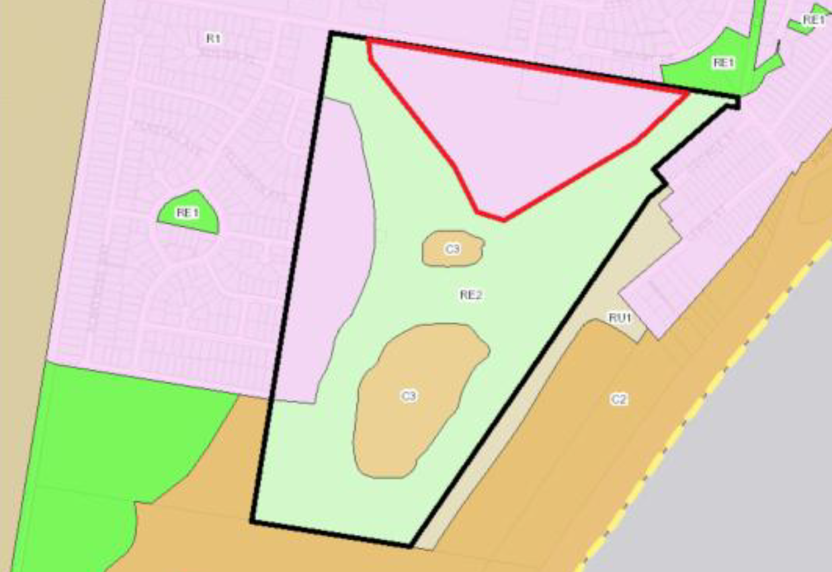

According to the definitions in Section 1.4 (contained in the Dictionary), the proposal satisfies the definition of Seniors Living which is a permissible use with consent in the Land Use Table in Clause 2.3.

The zone objectives include the following (pursuant to the Land Use Table in Clause 2.3):

- To provide for the housing needs of the community.
- To provide for a variety of housing types and densities.
- To enable other land uses that provide facilities or services to meet the day to day needs of residents.

The proposal is considered to be consistent with these zone objectives for the following reasons:

- The development contributes housing stock to meet the needs of the community.
- The development contributes housing variety to meet the needs of the community.

General Controls and Development Standards

The LEP also contains controls relating to development standards, miscellaneous provisions and local provisions. The controls relevant to the proposal are considered in Table 4 below.

Table 4: Consideration of the LEP Controls
Clause | Comments
Part 2 Permitted or Prohibited Development
2.7 Demolition requires development consent | Noted.  Notes: The development involves the demolition of existing structures located on the site. Conditions of consent relating to demolition have been included.
Part 4 Principal development standards
4.3 Height of Buildings | Compliant.  Notes: The development proposes single storey and two-storey dwellings across the whole development which are all below the permitted height limit of 8.5m.  Details of the dwellings associated have been provided which demonstrates compliance with the height of building standard.  - Max: 8.50m  - Proposed: 7.87m
4.4 Floor Space Ratio | Compliant.  Notes: The development conforms to the floor space ratio development standard. The development as a whole has a floor space ratio of 0.53:1 which is below the permitted 0.75:1.  - Max: 0.75:1  - Proposed: 0.53:1
Part 5 Miscellaneous provisions
5.10 Heritage conservation | Compliant.  Notes: The proposed development is not located within a heritage conservation area or within proximity to any items of heritage.  A basic AHIMS search (ID# 1148037) was conducted, and the search reveals three known items of aboriginal cultural heritage located within proximity to the proposed development. Of the three items, only two are located within the site boundaries, and the other is located outside of the site boundaries.  With regards for the items located within the site boundaries, the assessment of the bulk earthworks application, 229/2018/DA, provided the following statement in relation to the identified items:  “Aboriginal sites have previously been identified at the western boundary of the site. An updated due diligence assessment has been prepared which identified that the previously identified sites were destroyed, and did not identify any further sites in the precinct.”  Based on the above, there is no further consideration necessary for the proposal.
5.21 Flood planning | Compliant.  Notes: Consideration of flood impacts has been facilitated through other applications, namely the bulk earthworks application which identified that the resulting landform modification would result in a building area that would be above the flood planning level.  Based on this, it is considered that the development is satisfactory having regards for flood impacts and the development will remain above the applicable flood planning level.
Part 6 Urban release areas
6.1 Arrangements for designated state public infrastructure | Noted.  Notes: Arrangements have previously been satisfied through the provisions for Precinct 3.
6.2 Public utility infrastructure | Noted.  Notes: No public utility infrastructure required for Precinct 3.
6.3 Development control plan | Noted.  Notes: A DCP for Precinct 3 has been prepared and adopted by Council. This is contained within the Greater Taree DCP as part of the ‘Local Area Plans’.
Part 7 Additional land provisions
7.1 Acid sulfate soils | Compliant.  Notes: The site is mapped as containing potential Acid Sulfate Class 3 and Class 5 Soils.  Consideration of acid sulfate soils has been facilitated through the bulk earthworks application for the site. This was facilitated through the original assessment of 229/2018/DA (most recent approval being: MOD2025/0026).  An Acid Sulfate Soils Management Plan is not necessary in this particular case.
7.3 Earthworks | Compliant.  Notes: No significant earthworks are proposed as part of this proposal. Consideration of earthworks has been facilitated through the original assessment of 229/2018/DA for bulk earthworks on the site (most recent approval being: MOD2025/0026).
7.11 Essential services | Compliant.  Notes: The site is serviced by essential infrastructure including electricity.

The proposal is considered to be generally consistent with the LEP.

- Section 4.15 (1)(a)(ii) - Provisions of any Proposed Instruments

The Draft MidCoast Local Environmental Plan has been the subject of public consultation under the EP&A Act, and is therefore relevant to the proposal.

Under the provisions of the Draft MidCoast LEP, the site retains the same zonings. Multi dwelling housing remains permitted with consent in the R1 zone. The proposal is consistent with the relevant zone objectives.

There are no development standards or provisions of the Draft MidCoast LEP that would warrant amendment to, or prohibit, the development.

- Section 4.15(1)(a)(iii) - Provisions of any Development Control Plan

The Greater Taree Development Control Plan 2010 (DCP) is relevant to the application.

The aims of the Plan are to ensure good quality, sustainable development outcomes that maintain a high level of environmental amenity. The Plan is designed to allow flexibility in the application of its controls where strict compliance is considered unreasonable or unnecessary provided the relevant objectives of the Plan have been achieved.
The following is a summary of the evaluation of the proposal pursuant to the relevant provisions of the Plan.

Greater Taree Development Control Plan (DCP) 2010
Part B – Character Statement
Comment: The character statement for Old Bar is yet to be drafted. Noting this however, the development is considered to be compatible with the surrounding character and the intended future character for the area.

Part D – Environmental
Comment: The development satisfies the relevant objectives and performance criteria of Section D. Conditions of consent in relation to erosion and sediment control will be imposed.

Part G – Car Parking & Access
Comment: The development satisfies the relevant objectives and performance criteria of Section G. The specific matters are outlined below:

Part G1 – Car Parking and Access:
The development complies with the performance criteria of G:
- Car parking spaces are not located within 3.0m of the road alignment.
- Garage widths are at least 3.0m. Conditions of consent requiring all access and parking to be in accordance with AS2890.1 will be imposed.
- The development has a compliant driveway which exceed the 4.0m requirement. The development will be conditioned to require a driveway application. The final width of the driveway will be determined at this stage. The development can comply with the required width.
- Hardstand areas have been minimised and landscaping has been implemented across the site.

Part G1.1 – Location of Driveways:
The driveway associated with the development is appropriately located on the site and is clear of all obstructions and allows adequate visibility for vehicles entering and exiting the site. The development complies with the relevant performance criteria of G1.1. Conditions of consent requiring compliance with AS2890.1 will be imposed.

G1.2 Service Vehicle Requirements:
The applicant has demonstrated that the internal road network is capable of permitting appropriately sized service vehicles (including waste service trucks) to manoeuvre throughout the site.

G1.3 Parking Requirements for Specific Land Uses:
The development proposes a mixture of three-bedroom dwellings and two-bedroom dwellings. Accordingly, the development provides each dwelling with two (2) spaces (double garages). The number of spaces satisfies the requirements of Part G1.3.

A total of 204 dwellings are proposed, which requires a minimum of 68 visitor spaces. The development includes the provision of 69 visitor parking spaces. The spaces are considered to be appropriately positioned throughout the site.

G1.4 Car Parking Requirements:
The parking spaces have been correctly calculated.

Part H – Residential
Comment: The development satisfies the relevant objectives and performance criteria of Section H. The specific matters are outlined below:

Part H2.1 Site Coverage and Lot Requirements:
The development does not exceed the permitted 65% site coverage.

Part H2.2 Building Setbacks:
No zero lot line setbacks are proposed as part of the development.

Part H2.3 Building Height:
The development complies with the objectives and performance criteria pf Part H2.3. The development has a maximum height of 7.87m which is below the permitted 8.5m. The development also does not exceed three (3) storeys.

H2.4 Car Parking and Access:
The development complies with the objectives and performance criteria pf Part H2.3. Specifically, the following is noted:
- The garages do not dominate the frontage.
- The driveways are considered appropriate to facilitate the suitable access to the units.
- Hardstand areas have been minimised and landscaping has been implemented across the site.
- The design or parking and access has been appropriately considered by the designer. The development will be required to comply with AS2890.1.

Part H2.5 Private Open Space:
The development has been designed to achieve practical compliance with the performance criteria of H2.5.

Part H2.6 Solar Access and Overshadowing:
The development complies with the relevant objectives and performance criteria of Part H2.6. The units have been orientated to maximise north facing solar access.

Part H2.7 Acoustic and Visual Privacy:
The development complies with the relevant objectives and performance criteria of Part H2.7. The units have been appropriately designed to minimise the risk of impacts to acoustic and visual privacy.

Part H2.8 Views:
No views are impacted by the development. The development is considered satisfactory having regards for the objectives and performance criteria of Part H2.8.

Part H2.9 Safety, Security and Entrances:
The development generally complies with the relevant objectives and performance criteria of Part H2.9. The following is noted:

- All entrances to each unit are considered to be easily identified.
- Each unit has covered access to the front door.

Part H3.4 Multi Dwelling Housing:
He development is generally compliant with the relevant objectives and performance criteria of Part H3.4 as noted below:

Site Coverage:
The lot size exceeds 1,000m².

Setbacks:
The development does not include any front setbacks to the public road and only includes frontages to the internal private roads. It is considered that the setbacks provided are appropriate and can be supported.

Car Parking and Access:
Each unit has appropriate parking required. Each dwelling has two (2) spaces. Visitor parking spaces have also been provided throughout the development. The development proposes driveways of suitable width for each unit.

Private Open Space:
Each unit is considered to be provided with sufficient private open space for the intended occupants. Whilst not strictly conforming to the controls for private open space, the development is considered to provide appropriate levels of private open space for each dwelling, noting the provision of extensive communal open space within the development as well as the proposed community facilities.

Storage:
Sufficient storage space has been provided for each dwelling.

Part M – SWMM
Comment: The development has been reviewed against the relevant provisions of Part M. The development is considered to be satisfactory having regards for the applicable objectives and performance criteria and can be supported.

A Waste Management Plan has been submitted in support of the application. The Plan adequately addresses waste management procedures associated with the demolition, construction and the ongoing management of the site.

The applicant has demonstrated that there is sufficient space for the manoeuvring of waste vehicles, suitable space for collection areas and the details provided can conform with council requirements and regulations with regards for waste collection.

Part N – Landscaping
Comment: The development satisfies the relevant objectives and performance criteria of Section N. The specific matters are outlined below:

Part N1.4 Dual occupancy, multi-dwelling housing, residential flat buildings and mixed use development

The application has been supported by a landscape plan. The development is considered to be compliant with the performance criteria associated with Part N1.4 as follows:

- The development is considered to result in a suitable outdoor space which will contribute to a high level of amenity for occupants.
- Planting is considered appropriate for the site and locality and will provide a high level of amenity to the occupants as well as improving the overall streetscape.

- Section 4.15(1)(a)(iiia) – Planning agreements under Section 7.4 of the EP&A Act

There have been no planning agreements entered into and there are no draft planning agreements being proposed for the site.

- Section 4.15(1)(a)(iv) - Provisions of Regulations

Consideration has been given to the relevant provisions prescribed by the regulations being:

- Section 61 – Additional matters that consent authority must consider

In accordance with Section 61, consideration of the demolition of the existing structures, has been undertaken. Appropriate conditions of consent have been imposed on the consent.

  - Section 4.15(1)(b) – Significant Likely Impacts of Development

The significant likely impacts of that development, including environmental impacts on both the natural and built environments, and social and economic impacts in the locality must be considered. In this regard, potential impacts related to the proposal have been considered in response to SEPPs, LEP and DCP controls outlined above and the Key Issues section below.

The consideration of impacts on the natural and built environments includes the following:

Context and setting
The development is located on the urban fringe of Old Bar and forms n expansion of the existing built form. The development has been designed to be sympathetic to both the natural and built landform and is considered to be compatible with the local character.

The development has demonstrated through the plans and supplied reports that the proposal will be suitable having regards for context and setting and can be supported.

Access and traffic
Access to the development is proposed via an access point located at the intersection of Forest Lane and Wyden Street. Internal access roads traverse the site to allow for occupants and visitors to navigate the site. Suitable parking is also provided within the site to cater for both residents and visitors.

The applicant has demonstrated that the road network to get access to the site is suitable and has capacity to cater for the proposal without the need for significant upgrade.

The applicant has also demonstrated that all proposed internal access and parking within the development is compliant with the provisions of AS2890.1 and Planning for Bushfire 2019. Conditions of consent reflecting this will be imposed.

Overall, it is considered that the applicant has demonstrated that the development will not adversely impact on the road network and that it is suitable to cater for the intended traffic numbers. The development is considered to be suitable having regards for access and traffic impacts.

Streetscape/Visual Amenity
It is considered that the development forms a low-to-medium scale expansion of the existing urban fabric associated with the surrounding area. The development remains sympathetic to the existing character and presents dwelling designs which are contemporary whilst respecting the surrounding locality, including both the natural and built environments.

Dwelling facades provide appropriate variety and compatibility to avoid both a repeated or ‘staccato’ streetscape. Such situations can occur in other residential estates, where the streetscape can appear flat due to repeated design, or completely disjointed as designs do not complement each other. The applicant has provided a number of dwelling facades which demonstrates a common theme for the complex, whilst allowing for diversity and interest in the broader streetscape.

To this extent, it is considered that the development has appropriately configured the layout to maximise the opportunities of the site, whilst working within the limits of the site constraints. This is done without adversely impacting on the streetscape and utilises design features to lower the overall visual impact of the development. Overall, it is considered that the proposal has positively responded to the constraints on the site and has resulted in a development which sits within the broader locality without adversely impacting on the streetscape or overall visual amenity.

Utilities
The development site is provided with all essential services and utilities, including electricity, stormwater, sewer and potable water. These services are able to be connected to the proposed development, however, may require upgrade. Where upgrades are required, these matters would be addressed through the construction phase and have been conditioned accordingly.

Natural hazards
The site is partially mapped as bushfire prone land. The application was supported by a bushfire report, which was referred to NSW Rural Fire Service for consideration in accordance with Section 100B of the Rural Fires Act 1997. The application was supported by NSW RFS with general terms of approval (GTA) being issued in conjunction with their Bushfire Safety Authority. These GTAs have been included as conditions of consent.

Safety, security and crime prevention
The development is considered to be designed to meet CPTED principles and provides appropriate casual surveillance across, and within, the site as well as into the public domain.

Economic and Social Impacts
It is considered that the development will result in net positive social and economic impacts. Specifically, the following is noted:

Social Impacts: The development provides additional housing to cater for the needs of the Old Bar area as well as the broader region.

Economic Impacts: The development will result in both short-term and long-term economic benefits. Short-term benefits result from the increase in economic activity during the construction phase through the employment of construction workers, and the possible flow on effects of economic activity form these works (in the event they are transient workers).

Long-term benefits include additional population growth for the area and the economic activity that this would contribute to in both the surrounding area as well as the broader LGA.

Overall, it is considered that, on balance, the development results in positive social and economic impacts and can be supported.

Site design and internal design
The development is considered to be suitably designed to allow the safe movement of both pedestrians and vehicles within the proposal. Clear separation between vehicle access and pedestrian access has been established to assist with this.

The configuration of the dwellings is considered appropriate for the ongoing use by future occupants. In addition to this the dwellings have been appropriately configured to provide appropriate living conditions that do not adversely impact the occupants.

Overall, the development is considered to be suitably designed to allow for the safe use of future occupants.

Construction
Construction activities associated with the development have the potential to result in impacts on the surrounding area and adjoining developments.

Conditions of consent have been imposed to address these potential impacts and includes construction hours, erosion and sediment control, waste management, demolition, construction management, and traffic management.

Cumulative impacts
The combination of any of the impacts identified in this report are not considered to result in any cumulative impacts which would warrant the modification or refusal of the application.
Accordingly, it is considered that the proposal will not result in any significant adverse impacts in the locality as outlined above.

  - Section 4.15(1)(c) - Suitability of the site

Based on the assessment contained within this report, the development appropriately responds to the site constraints and opportunities. The site's attributes are conducive to supporting the development when considering the road network, topography, and existing infrastructure. The development has established a layout that is compatible with the broader locality and sits within the area's landscape.

In summary, the development has adequately addressed the site limitations and opportunities, and, all things considered, the site attributes are conducive to supporting the development.

  - Section 4.15(1)(d) - Public Submissions

Submissions are considered in Section 5 of this report.

  - Section 4.15(1)(e) - Public interest

The development satisfactorily addresses Council’s criteria and would provide a development outcome that, on balance, would result in a positive impact for the community. Approval of the development would be in the public interest.

- DEVELOPER CONTRIBUTIONS

In accordance with councils Greater Taree Section 94 Contributions Plan 2016 the development is required to pay contributions associated with the proposed development.
The contributions are based on the number of dwellings and the bedroom configuration of each dwelling. Accordingly, there is a total of 204 units, being a combination of 21 two-bedroom dwellings and 183 three-bedroom dwellings. There is also a credit for the existing lot which will be applied to the first payment of contributions.
The development breakdown for staging is as follows:
Stage | No. Dwellings | Two-Bedroom Dwellings | Three-Bedroom Dwellings
1. | 27 | 7 | 20
2. | 26 | 1 | 25
3. | 24 | - | 24
4. | 20 | - | 20
5. | 28 | 4 | 24
6. | 17 | 3 | 14
7. | 23 | 3 | 20
8. | 27 | 3 | 24
9. | 12 | - | 12
Total | 204 | 21 | 183

The development is located within the ‘Old Bar Precinct 3’ local contributions catchment. The base contributions for the development are identified in the below table. Contributions will be required to be paid prior to installation of each manufactured home. Conditions of consent will be imposed that require these to be paid prior to issue of a Section 68 approval for installation for each manufactured home.
Table 5: Contribution Amounts Per Dwelling - Derived from July 2026 Figures
Old Bar Precinct 3 Local Catchment
Two-Bedroom Dwellings
Catchment Facilities | Contribution
Local Facilities | $12,472.18 / Dwelling
Greater Taree Facilities | $2,960.21 / Dwelling
Total | $15,432.39 / Dwelling
Three-Bedroom Dwellings
Catchment Facilities | Contribution
Local Facilities | $18,957.72 / Dwelling
Greater Taree Facilities | $4,499.51 / Dwelling
Total | $23,457.23 / Dwelling

- REFERRALS AND SUBMISSIONS

  - Agency Referrals and Concurrence

The development application has been referred to various agencies for comment/concurrence/referral as required by the EP&A Act and outlined below in Table 5.

There are no outstanding issues arising from these concurrence and referral requirements subject to the imposition of the recommended conditions of consent being imposed.

Table 7: Concurrence and Referrals to agencies
Agency | Concurrence/  referral trigger | Comments  (Issue, resolution, conditions) | Resolved
Integrated Development (S 4.46 of the EP&A Act)
RFS | Section 100B - Rural Fires Act 1997 | The proposal is located on bushfire-prone land, and is identified as requiring an ‘integrated approval’ pursuant to Section 100.b of the Rural Fires Act 1997.  The application has been referred to the NSW RFS for comment. The NSW RFS has issued a Bush Fire Safety Authority supporting the application.  The application has satisfied the requirements under the Rural Fires Act 1997. | Y
DPE - Water | Section 91 – Water Management Act 2000 | The application identified works within mapped watercourses which was considered to require a Controlled Activity Approval.  The application was referred to the Department of Planning and Environment - Water pursuant to Section 91 of the Water Management Act 2000 No 92.  The Department of Planning and Environment - Water advised that the development was not considered to be on waterfront land and therefore did not require a Controlled Activity Approval. | Y

  - Council Officer Referrals

The development application has been referred to various Council officers for technical review as outlined in the table below:

Table 8: Consideration of Council Referrals
Officer | Comments | Resolved
Development Engineering | Council’s Development Engineering team reviewed the application having regards for traffic impacts and stormwater management.  The assessment by Development Engineering concluded that the application could be supported subject to appropriate conditions of consent being imposed. | Y
Building Services | Council’s Building Services team reviewed the application having regards for matters associated with National Construction Codes (NCC) and Building Codes of Australia (BCA) compliance. In addition to this the Building Services team also had consideration for conditions and requirements relating to building certification construction certificates.  The assessment by the Building Services team concluded that the application could be supported subject without the need for any specific conditions, noting that the proposal would not require a construction certificate. | Y
Ecology | Council’s Ecology team reviewed the application having regards for matters associated with impacts on flora and fauna as well as compliance with the relevant biodiversity legislation.  The assessment by the Ecology team concluded that the application could be supported without any specific conditions, noting that vegetation removal has been approved and conditioned under other DAs associated with the site. | Y
Water Services | Council’s Water Services team reviewed the application having regards for matters associated with water and sewer infrastructure and servicing.  The assessment by the Water Services team concluded that the application could be supported subject to appropriate conditions of consent being imposed. | Y
Water Quality | Council’s Water Quality team reviewed the application having regards for water quality associated with stormwater management.  The assessment by the Water Quality team concluded that the application could be supported subject to appropriate conditions of consent being imposed. | Y

  - Community Consultation

The application as originally made was exhibited from 11 August 2025 to the 15 September 2025 accordance with the Environmental Planning and Assessment Act 1979, Environmental Planning and Assessment Regulation 2021 and the MidCoast Council Community Engagement Strategy.

Council received zero (0) submissions during the community consultation process.

- CONCLUSION

This development application has been considered in accordance with the requirements of the EP&A Act and the Regulations as outlined in this report. Following a thorough assessment of the relevant planning controls, issues raised in submissions and the key issues identified in this report, it is considered that the application can be supported.

It is considered that the key issues have been resolved satisfactorily through amendments to the proposal and/or in the recommended draft conditions at Attachment A.

- RECOMMENDATION

That the Development Application DA205/0571 for a 204 Multi-dwelling Development at Lot 2 DP 1022067, 106 Forest Lane, Old Bar be APPROVED pursuant to Section 4.16(1)(a) or (b) of the Environmental Planning and Assessment Act 1979 subject to the draft conditions of consent attached to this report at Attachment A.

The following attachments are provided:

- Attachment A – Draft Conditions
- Attachment B – Plans
- Attachment C – Staging Plan
- Attachment D – Statement of Environmental Effects
- Attachment E – Civil Plans
- Attachment F – Stormwater Letter
- Attachment G – Bushfire Report
- Attachment H – Traffic Report
- Attachment I – Traffic Report Addendum
- Attachment J – Statement of Landscape Intent
- Attachment K – Flood Imperviousness Assessment
- Attachment L – Waste Management Plan

